CRANFIELD UNIVERSITY

Wei Luo

A Machine Learning-based Framework for Real-time Assessment of Battery Corrosion in Battery Management System (BMS)

School of Aerospace, Transport and Manufacturing

Aerospace Manufacturing

MSc

Academic Year: 2019 - 2020

Supervisor: Dr Maadhav, Kothari

Associate Supervisor: Dr Simon, Gray

August 2020

CURES/ETHICS APPROVAL REFERENCE:

CURES/11594/2020

ABSTRACT

This thesis presents a framework to measure corrosion of batteries within Battery Management System (BMS) for maintenance activity. It presents the use case of Electrochemical Impedance Spectroscopy (EIS) as a non-destructive inspection method to detect battery states. Multiple cycles (charge and discharge) were done to gain EIS results in different status. Results were captured and digitalised through a suitable circuit model and mathematical methods for fitting. The values of State of Health (SoH) were calibrated and data are reshaped as vectors and then used as input for Support Vector Machine (SVM). These data were then used to create a machine learning model and analyse the aging mechanism of lithium-ion batteries. Various kernel functions are used to generate machine learning models, and their pros and cons are compared. The machine learning model is established, and the decision boundaries are visualised in both 2D and 3D graphs. As the accuracy of these machine learning models can reach 100% in the test cases, the framework allows more reliable SoH estimation in electric vehicles and more efficient maintenance operations.

Keywords:

Lithium-ion, Aging, Electrochemical Impedance Spectroscopy, Data Processing, Support Vector Machine, Parameter Identification, Visualisation

ACKNOWLEDGEMENTS

The author would like to acknowledge supervisors Dr. Adnan, Syed, Mr Maadhav, Kothari, and Dr. Simon Gray for their professional academic and personal support which is essential to the success of the thesis. The author also acknowledges Surface Engineering and Precision Institute of Cranfield University for help and direction. Similarly, the author also acknowledges the staff from AMETEK, Inc. for their technical support on instruments.

TABLE OF CONTENTS

ABSTRACT i

ACKNOWLEDGEMENTS ii

LIST OF FIGURES v

LIST OF TABLES vii

LIST OF ABBREVIATIONS viii

1 Introduction 1

1.1 Aim 2

1.2 Objectives 2

1.3 Deliverables 3

2 Literature Review 4

2.1 Electrochemical Impedance Spectroscopy (EIS) 4

2.1.1 Principle of EIS 4

2.1.2 Equivalent Circuit Model (ECM) 6

2.2 Battery Management System 9

2.2.1 Basic Structure and Responsibilities 9

2.2.2 Implement EIS within BMS 10

2.3 Machine Learning Algorithm 11

2.3.1 K Nearest Neighbours (KNN) 12

2.3.2 Support Vector Machine (SVM) 13

3 Methodology 15

3.1 Experiment Preparation 15

3.1.1 Experiment Equipment 15

3.1.2 Experiment Setup 16

3.1.3 Experimental Procedure 19

3.2 EIS Data Fitting 20

3.2.1 Post-processing 20

3.2.2 Fitting 21

3.3 Machine Learning Implementation 22

4 Results and Analysis 24

4.1 Fitting Results 24

4.2 EIS Results and Analysis 25

4.2.1 Battery Aging Situation and SoH Calibration 26

4.2.2 Longitudinal Comparison (Quantitative) 27

4.2.3 Horizontal Comparison (Qualitative) 30

4.3 Machine Learning Results 31

5 Discussion 35

5.1 Validation Process 35

5.2 Validation Results 35

5.2.1 Boundary Plot using Different Kernel Function 35

5.2.2 Accuracy 38

6 Conclusion 40

6.1 Result Achieved 40

6.2 Obstacles Faced 40

6.3 Future Work 40

REFERENCES 42

APPENDICES 43

# LIST OF FIGURES

[Figure 2‑1 impedance response of R and C circuit 5](https://cranfield-my.sharepoint.com/personal/wei_luo_cranfield_ac_uk/Documents/IRP%20private/Thesis.docx#_Toc49247396)

[Figure 2‑2 impedance response of only C circuit 5](https://cranfield-my.sharepoint.com/personal/wei_luo_cranfield_ac_uk/Documents/IRP%20private/Thesis.docx#_Toc49247397)

Figure 2‑3 Schematic diagram of EIS Reference? 5

Figure 2‑4 A typical response of an electrochemical reaction 6

[Figure 2‑5 Schematic diagram of Rint model 7](https://cranfield-my.sharepoint.com/personal/wei_luo_cranfield_ac_uk/Documents/IRP%20private/Thesis.docx#_Toc49247400)

Figure 2‑6 Schematic diagram of PNGV model 7

Figure 2‑7 Schematic diagram of GNL model 8

Figure 2‑8 Simplified Battery Management System 10

Figure 2‑9 BIT-BMS (Bliss G. Carkhuff, 2018) 11

Figure 2‑10 Principle of KNN 12

Figure 2‑11 Principle of SVM 13

Figure 2‑12 Kernel Functions 14

Figure 3‑1 Battery Appearance 16

Figure 3‑2 Versastat 3F 16

Figure 3‑3 Two Electrode Connection 17

Figure 3‑4 Experiment Properties 17

Figure 3‑5 Impedance Data 18

Figure 3‑6 Nyquist diagram 18

Figure 3‑7 Experimental Procedure 19

Figure 3‑8 Smoothed Data Curve 20

Figure 3‑9 Equivalent Circuit Model 21

Figure 3‑10 Sample Fitting Results 22

Figure 3‑11 Training Data 23

Figure 4‑1 Fitting Results after the 1st Cycle 24

Figure 4‑2 Fitting Results after the 30th Cycle 25

Figure 4‑3 Capacity vs Cycle number 26

Figure 4‑4 Nyquist Diagram of the 1st Cycle and the 30th Cycle 27

Figure 4‑5 Changes of Each Resistor (1st vs 30th) 28

Figure 4‑6 Nyquist Diagram of the 30th Cycle and the 50th Cycle 28

Figure 4‑7 Changes of Each Resistor (30th vs 50th) 29

Figure 4‑8 3 Stages of Battery Corrosion 29

Figure 4‑9 Nyquist Diagram of Multiple Experiments After the 1st Cycle 31

Figure 4‑10 Changes of Rct 31

Figure 4‑11 R0 vs R1 Before Training 32

Figure 4‑12 R0 vs R2 Before Training 32

Figure 4‑13 R1 vs R2 Before Training 32

Figure 4‑14 R0 vs R1 After Training 33

Figure 4‑15 R0 vs R2 After Training 33

Figure 4‑16 R1 vs R2 After Training 33

Figure 4‑17 3D Decision Boundaries 34

Figure 5‑1 Decision Boundaries using Linear Kernel Function (R0 vs R1) 35

Figure 5‑2 Decision Boundaries using Linear Kernel Function (R0 vs R2) 36

Figure 5‑3 Decision Boundaries using Linear Kernel Function (R1 vs R2) 36

Figure 5‑4 Decision Boundaries using Polynomial Kernel Function (R0 vs R1) 36

Figure 5‑5 Decision Boundaries using Polynomial Kernel Function (R0 vs R2) 37

Figure 5‑6 Decision Boundaries using Polynomial Kernel Function (R1 vs R2) 37

Figure 5‑7 Time Consumption Comparison 37

LIST OF TABLES

Table 2‑1 2 Simplified 2D Data 12

Table 3‑1 Battery Specifications 15

Table 3‑2 Initial Guess for Fitting 22

Table 4‑1 Correspondence Table of Cycle Times and SoH 26

Table 4‑2 Example Data for Machine Learning SoH Estimation 34

Table 5‑1 Verification Data 35

Table 5‑2 Validation Results 36

LIST OF ABBREVIATIONS

|  |  |
| --- | --- |
| EV  BMS  SoH | Electric Vehicle  Battery Management System  State of Health |
| ASoH | Absolute State of Health |
| RSoH | Relative State of Health |
| SoF  SoC  ASoC  RSoC  RUL  OCV  EIS  ECM  ML  SVM  SEI | State of Function  State of Charge  Absolute State of Charge  Relative State of Charge  Remain Useful Life  Open Circuit Voltage  Electrochemical Impedance Spectroscopy  Equivalent Circuit Model  Machine Learning  Support Vector Machine  Solid Electrolyte Interphase |

# Introduction

With the increasing demand of energy on earth and the growing awareness of human and environmental protection concept, Electric vehicles (EVs) has become a demanding vehicle type in both developed and some developing countries.

Considering a single cell battery pack, a constant charge and discharge rate within a full cycle can easily reach its maximum battery life. However, a high-power large capacity battery that drives an EV’s engine is usually made up of many single battery packs connected in series or parallel. As each of the battery pack varies in quality, an imbalance among the battery pack will appear over time, which may reduce the remain useful life (RUL) to a large extent and sometimes leads to failure. To slow down or suppress this situation, manufacturers have developed a battery management system (BMS) for Li-ion batteries based on the BMS for lead-acid batteries used in gasoline vehicles. A BMS is implemented to monitor the condition of the battery using some specific parameters (e.g. voltage, current, and temperature) and take proper measurements to provide battery safety and longevity.

The emergence of BMS has undoubtedly made the batteries of electric vehicles more durable. However, most of the consumers are unaware of basics of battery except the only parameters provided by the BMS. For example, consumers and maintenance agents can only choose to trust the percentage of the state of charge (SoC) displayed on the dashboard to determine how much power is left in the battery. Many cases have been reported where customers battery operated mobile phones or EVs shutdown suddenly although the battery power indicator was still showing above 20%. The battery aging makes the traditional coulomb counting or SoC-OCV prediction method less reliable.

The electrochemical impedance spectroscopy (EIS) testing method can be carried out in any electrochemical reaction stage (charge or discharge), and at the same time does not cause any loss to the battery during the test process, so it can better reflect the true state of the battery. Using EIS in Li-ion batteries has become a popular topic for identifying degradation patterns. Although EIS test instruments are usually in the lab, due to its broad prospects, some companies have also launched a series of chips to make it possible to apply EIS testing within a BMS.

Many publications indicate that predicting current SoC and temperature of the battery by using EIS data is feasible (XI An-jing, 2012, Zhang Caipin, 2013) as values from some elements in the equivalent circuit model (ECM) follow a significant trend during aging or changing in temperature. However, few studies have explored the relationship between the state of health (SoH) and EIS data as SoH is the result of the combined effect of changes in various element values in the ECM. This thesis will try to consider multiple effects from the ECM and give a relatively accurate SoH value by machine learning.

In this thesis, Chapter 1 lists the aim, objectives, and deliverables of the thesis. Chapter 2 reviews the current studies and technologies in BMS, EIS, and some popular machine learning algorithms. In Chapter 3, selections of methodology to meet the aim are discussed and results are presented in Chapter 4. A review of the results is provided in Chapter 5. This report ends with the conclusion and future works in Chapter 6.

## Aim

The thesis aims to predict health information of batteries by the machine learning model, which is trained by EIS data from known batteries, and help users and maintenance agents to supervise the batteries’ aging situation to get a replacement at the proper time.

## Objectives

1. Generate and automatically extract and process battery data from EIS testing experiments.
2. Reshape and split the data to training data and testing data
3. Use machine learning algorithms to generate a classification model for different health status by using training data.
4. Return the SoH of testing data and validate the model by comparing the known experimental conditions and machine learning predictions.

## Deliverables

1. A client that can automatically process the EIS raw data and do post processing compatible with machine learning.
2. A trained machine learning model for battery EIS data and be able to return an SoH by giving another dataset after postprocessing.
3. Project Thesis and Poster Structure of the thesis.

# Literature Review

This chapter explores the current state of technologies used to test battery and provide their safety and longevity. Apart from the battery perspective, popular machine learning algorithms used in data analysis will also be discussed. The first part of the review will focus on the principle of the EIS testing method and how can it be used in battery testing. After that, a review of BMS will be presented including their structure and responsibilities. Meanwhile, combined with some publications and relevant news on the internet, it will explain a way to integrate EIS testing in the BMS in detail. Finally, the principles of machine learning like K Nearest Neighbours (KNN) and Support Vector Machine (SVM) algorithm will be introduced.

## Electrochemical Impedance Spectroscopy (EIS)

As the electrochemical reactions happened inside a battery are very complicated, electrochemical impedance spectroscopy (EIS) offers an efficient way to separate them. Advances in frequency response analysers and IT technologies have made the accuracy of EIS much higher and more automated.

### Principle of EIS

To better explain the principle of EIS, thinking about the similarity between chemical reactions and circuits. Both of them will generate a current signal after a voltage signal is applied and the relationship between them complies with Ohm’s Law:

 (Equation 2‑1)

In a DC circuit, the block to current is called resistance while in the AC circuit, it is called impedance. If the input voltage has a certain frequency, the current obtained will also follow this frequency, and the impedance will change according to the frequency. As impedances consist of both size and direction, they are often described as imaginaries where the magnitude describes the size and the phase describes the direction. A circuit with an only capacitor C and a circuit with capacitor C and resistor R in series will show the response of 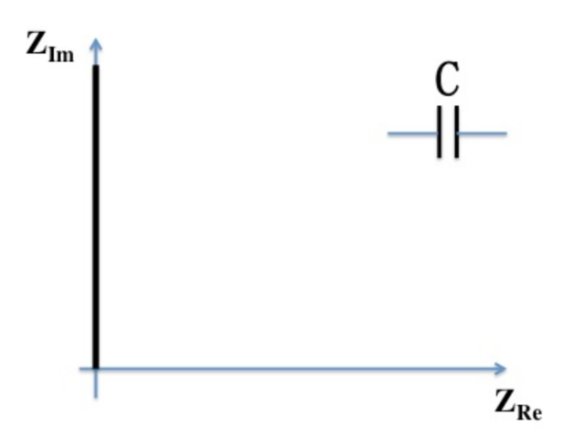impedance as Figure 2-1 and Figure 2-2.

Figure 2‑1 impedance response of R and C circuit

Figure 2‑2 impedance response of only C circuit

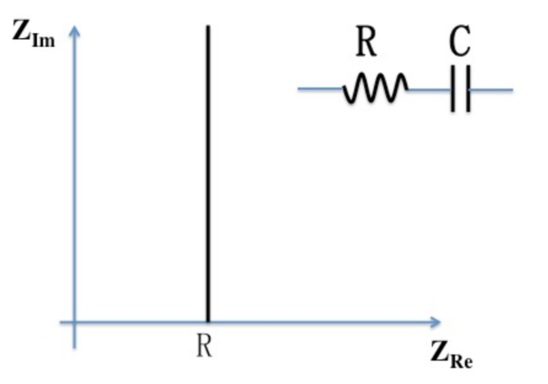The core of EIS is to imagine the electrochemical reaction as impedance and analyse the trend. By using signals of different frequencies to scan an electrochemical reaction (Figure 2-3), a response such as Figure 2-4 can be obtained. This kind of diagram is called the Nyquist diagram.

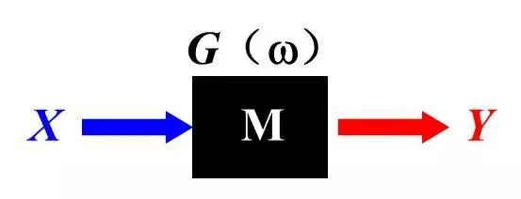

Figure 2‑3 Schematic diagram of EIS Reference?

Figure 2‑4 A typical response of an electrochemical reaction (A. Bard, 2001)

In Figure 2-4:

: Ohmic resistance

: Solid Electrolyte Interphase (SEI) layer resistance

: Charge transfer resistance

### Equivalent Circuit Model (ECM)

According to the results of various test methods, people have proposed many equivalent circuit models of batteries, from the simpler Rint model to the PNGV model that has been popular in recent years. The following will briefly introduce several models.

#### Rint Model

The Rint model, as shown in Figure 2-5, equivalents the battery as a series of an ideal voltage source and a resistance . is the terminal voltage and can be calculated by Equation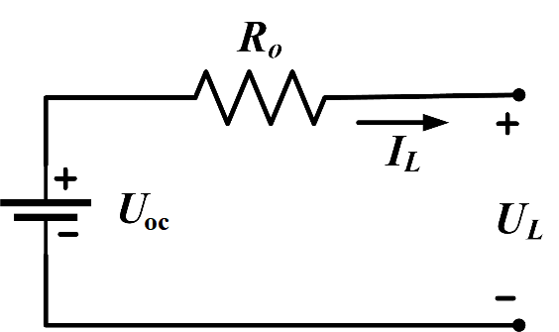 2-2.

Figure 2‑5 Schematic diagram of Rint model

 (Equation 2‑2)

#### PNGV Model

The “Partnership for a New Generation of Vehicles (PNGV)” model is first proposed by the U.S. Department of Energy in the “PNGV Battery Test Manual” in 2001. It is also the standard model in battery experiments in the “FreedomCAR Battery Test Manual” in 2003.

In the PNGV Model (Figure 2-6), resistance R1 and capacitor C1 are introduced to describe the polarization process of the battery, while C0 will change the open-circuit voltage as the load current accumulates over time.

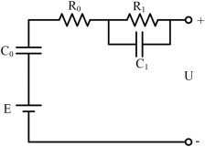

Figure 2‑6 Schematic diagram of PNGV model

#### GNL Model

The “General Nesting Logit (GNL)” model is proposed based on the second order PNGV model (Figure 2-7) to accurately reflect the dynamic characteristics of the battery. Rs is used to define self-discharge internal resistance.

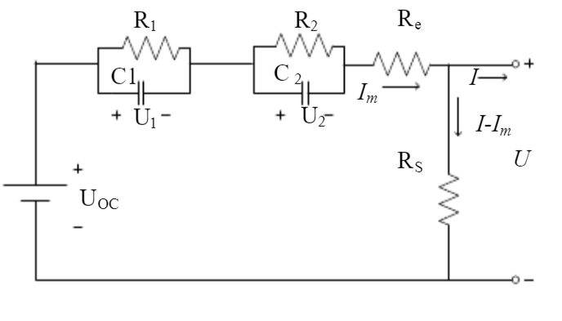

Figure 2‑7 Schematic diagram of GNL model

## Battery Management System

Battery Management System (BMS) offers a platform to monitor the working condition of the battery. As early as 1998, in response to the monitoring needs of lead-acid batteries, people have already developed BMS and is widely used even today. Although the type of the vehicle battery has changed during this period, from lead-acid batteries to lithium-ion batteries, the basic structure of the BMS has never changed. In this section, a simplified BMS structure and its responsibilities will be discussed. Meanwhile, several discoveries of implementing EIS within BMS will also be introduced.

### Basic Structure and Responsibilities

Figure 2-8 shows a simplified battery management system provided by Texas Instruments in 2011. Batteries are connected in series and next to the cell, there are cell monitoring blocks, and the cell balancing parts block. All of the blocks are able to measure single-cell voltages, current, and the temperature information through temperature sensors will be sent to the microcontroller and do proper balancing measurements. The switch in the upper right corner allows the BMS to safely cut off the circuit when the battery is faulty.

The key functions of a basic BMS often include:

1. Provide battery safety and longevity.
2. Reveal SoF in the form of SoC and SoH.
3. Prompt caution and service, which includes high temperature, cell imbalance, or calibration.
4. Indicate the end-of-life when the capacity falls below the target threshold.

Figure 2‑8 Simplified Battery Management System (Texas Instruments, 2011)

### Implement EIS within BMS

Commercial impedance testing has a wide range of capabilities, but they are rarely used within BMS due to their size, weight, and power consumption. However, because of the advantages of using EIS are far greater than its disadvantages, some teams and companies have developed BMS that can apply EIS multiple frequency test.

In 2018, Bliss G. Crakhuff’s team designed a new BMS called “BIT-BMS” (Figure 2-9) that allows BMS to do the EIS test at multiple frequencies in the 1 Hz to 1kHz range. Although the frequency sweep range is limited, it is a significant step for applying EIS testing within BMS, which means that a BMS capable of measuring impedance can meet the needs of most batteries.

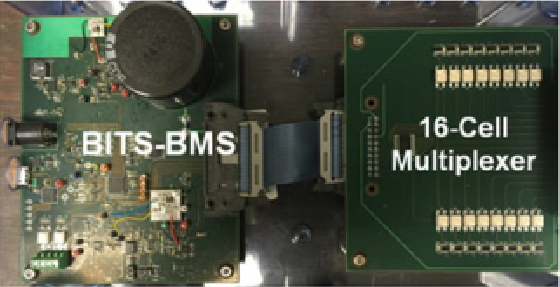

Figure 2‑9 BIT-BMS (Bliss G. Carkhuff, 2018)

The BIT-BMS is designed to monitor each of up to 16 cells in a multicell battery with no limit on the charge and discharge rates while the size remained almost unchanged compared to original BMS (10 x 10cm unit). It requires no computer control to operate but provides a USB port to export the data. For accuracy, the maximum resolution of a phase can be reached in 0.0123° (70 Hz, Bliss G. Carkhuff, 2018).

The same year, Datang Telecom Technology Co, Ltd in China also announced that they have developed a battery monitoring chip based on EIS technology. “Unlike traditional battery monitoring chips, it innovatively integrates voltage, impedance, and temperature monitoring functions into one, thereby achieving a perfect combination of electronic technology and electrochemical technology.”, said Datang.

## Machine Learning Algorithm

Various kinds of machine learning algorithms have been widely used in data mining. In this section, two machine learning algorithms that may able to implement to analyse battery EIS data will be introduced (KNN and SVM). They aim to generate a classifier through mathematical methods and decide which category belongs to when encountering a piece of new data. To better explain and visualise what is happening during the calculation, the Simplified 2D dataset will be used as examples (Table 2-1).

|  |  |  |
| --- | --- | --- |
| Category | Feature 1 | Feature 2 |
| 0 | Value 01 | Value 02 |
| 1 | Value 11 | Value 12 |

Table 2‑1 2 Simplified 2D Data

### K Nearest Neighbours (KNN)

K Nearest Neighbours (KNN) algorithm is the easiest algorithm to understand in machine learning as it can be easily implemented without requiring any mathematical foundation. The principle of KNN is to determine the category by counting the closet K points.

Figure 2-8 shows how the KNN works. Firstly, all the training data must be plotted in an n-dimensional space (the value of n depends on the number for features, a 2D graph in this case). The blue triangle points all belong to category 1 while red dot points are category 2. The green square point is the data needed to be predicted.

After setting the value of K, use the data to be predicted as the center of the circle, make a circle so that the circle includes exactly K nearby data points. Count the categories to which the K points belong, and the dominant category is used as the category of the data to be predicted.

Figure 2‑10 Principle of KNN

It is not hard to surmise that the accuracy of KNN depends on the value of K. For example, in Figure 2-10, if K is set to 3, the machine will predict the data as a blue triangle while if K equals to 5, the data will be regarded as a red dot by the program. Therefore, the value of K is the key to a well-trained machine learning model.

### Support Vector Machine (SVM)

The aim of Support Vector Machine (SVM) is to calculate a boundary that can equally divide the data into different categories (Figure 2-11).

Figure 2‑11 Principle of SVM

The boundary is decided to reach the maximum margin and the data points intersect with the two parallel boundaries are called “Support Vectors”. The process of finding the boundary is an optimisation problem that can be written as Equation 2-3 and is a parameter used to describe the boundary in higher dimension:

 (Equation 2‑3)

To solve this problem, the “Laplace Operator” can be used. However, this is not the focus of this thesis.

The equation mentioned above can only solve linearly separable data, which means that the boundaries are usually shown as lines. For non-linearly separable data, people use kernel functions to map low-dimensional data to high-dimensional space in order to convert non-linearly separable to linearly separable (Figure 2-12).

Figure 2‑12 Kernel Functions (Jeremy Jordan, 2017)

Similarly, the principle of different kinds of kernel functions is also not the focus of this thesis. However, the correct choice of kernel functions and their parameters are important due to their direct effect on the accuracy of the model and the training time.

# Methodology

This section consists of three parts. In the first part, general information about the equipment used as well as experiment properties will be introduced. “EIS Data Fitting” will explain in detail how to use “impedance.py” to automatically fit EIS curves. This section will be ended with the SVM implementation, which is the main data analysis tool in this thesis.

## Experiment Preparation

### Experiment Equipment

In this thesis, the battery model used is RS PRO 11.1V Lithium-ion Rechargeable Battery Pack, which is connected by 6 18650 battery cells. The detailed specifications are as follows:

|  |  |
| --- | --- |
| **Attribute** | **Value** |
| Chemistry | Lithium-Ion |
| Nominal Voltage | 11.1V |
| Number of Cells | 6 |
| Capacity | 5.2Ah |
| Terminal Type | Wire Lead |
| Size | 55 x 68 x 41 mm |
| Operating Temperature Range | -20 → +60°C |

Table 3‑1 Battery Specifications

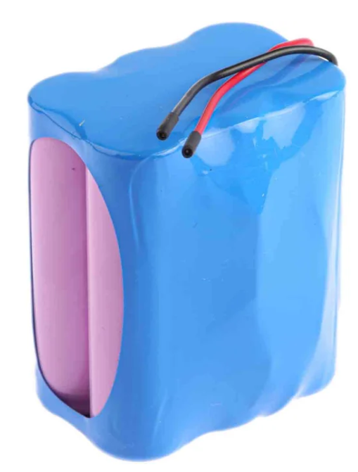

Figure 3‑1 Battery Appearance

Versastat 3F Electrochemical Workstation developed by Princeton Applied Research is ideal equipment in this experiment to keep charging and discharging the battery and do the EIS test within a single device.

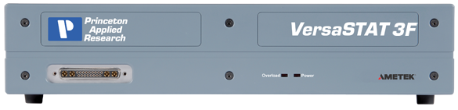

Figure 3‑2 Versastat 3F

### Experiment Setup

Versastat 3F manual indicates three ways to connect the electrochemical cell to the terminal of the cell cable. For a finished battery, as the electrode materials are all encapsulated in a shell, it is suitable to adopt two-electrode connection (Figure 3-3), where the working electrode (WE) and sense electrode (SE) are all connected to the positive electrode of the battery while counter electrode (CE) and the reference electrode (RE) are connected to the negative one.

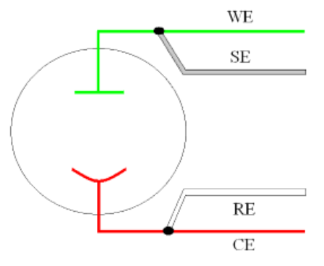

Figure 3‑3 Two Electrode Connection (Princeton Applied Research, 2003)

After the battery is connected, EIS experiment parameters can be set. Although VersaStudio has already provided many default settings, the start and end frequency and the amplitude must be adjusted to get EIS style curves as Figure 2-4. After several attempts, suitable experiment properties are as follows:

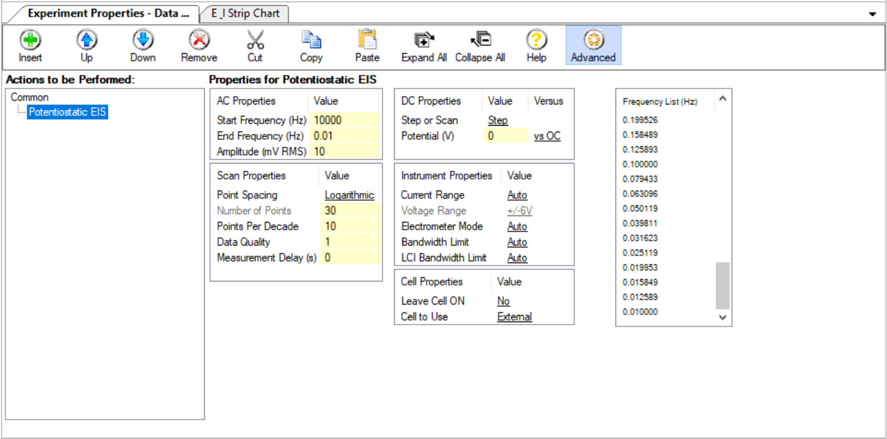

Figure 3‑4 Experiment Properties

By clicking the run button of VersaStudio, the workstation will start the EIS test and the current excited by specified sinusoidal voltage signal will be automatically measured to calculate impedance (Figure 3-5). The Nyquist diagram will then be generated (Figure 3-6), which is in the style like Figure 2-4. Export the data to Zview (.z) for easy processing with Python.

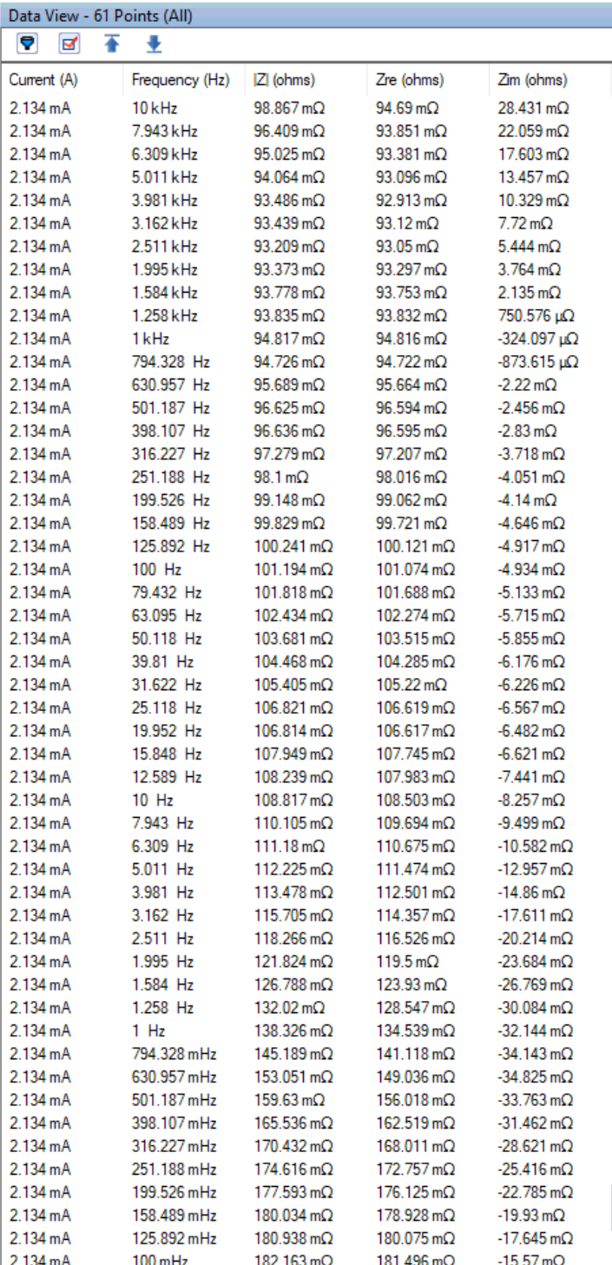

Figure 3‑5 Impedance Data

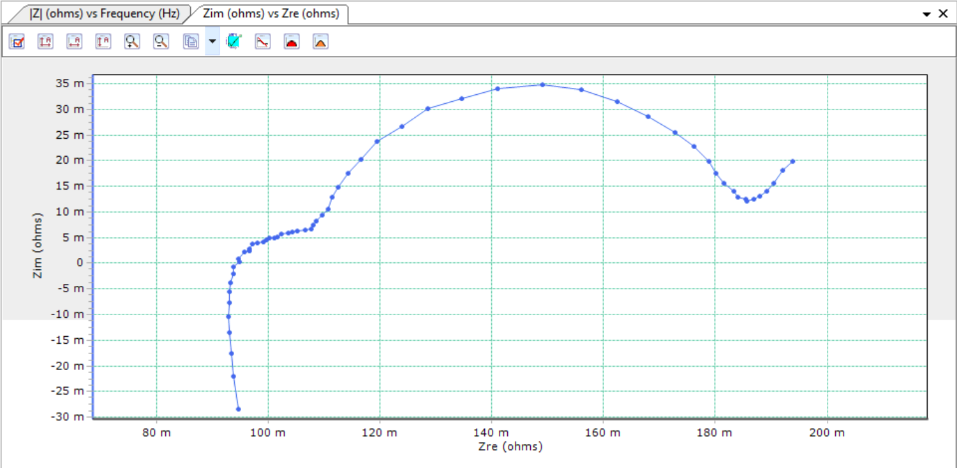

Figure 3‑6 Nyquist diagram

### Experimental Procedure

Batteries were run through 3 different operational profiles (charge, discharge and impedance) at room temperature. The charge was carried out in constant current (CC) mode at 2A until the battery voltage reach 4.2V and continue charging at constant voltage (CV) mode at 4.2V until the current drop below 200mA. The discharge was carried out in the same mode until the voltage drop to 2.7V. Repeated charge and discharge cycles result in accelerated aging of the battery while impedance measurements provide insight into the internal battery parameters that change as aging progresses. After the 1st, 30th and 50thcycle, take the EIS test 10 times respectively to get enough training data for machine learning. Figure 3-7 is a flow chart of experimental procedure.

Figure 3‑7 Experimental Procedure

## EIS Data Fitting

There are various kinds of software for impedance fitting (Zview, ZsimpWin), but most of them cannot automate processing for a large amount of data. “Impedance.py” is a project started at the 2018 Electrochemical Society (ECS) Hack Week in Seattle, aiming to create Python API for impedance analysis (data pre-processing, model fitting and visualisation). This thesis will mainly use such kind of tool, supplemented by the slight use of Zview.

### Post-processing

In Figure 3-8, it is not hard to notice that some non-perfect points are shown in the corner of the arc and the straight line, which may result in impedance fitting not accurate enough. Therefore, the first step of post-processing is to eliminate the influence of these points.

Export the data to Zview, use the slider on the top to locate the point to be deleted. Select Tools-Delete Data Point to remove it. Repeat the operation manually to make the curve smooth.

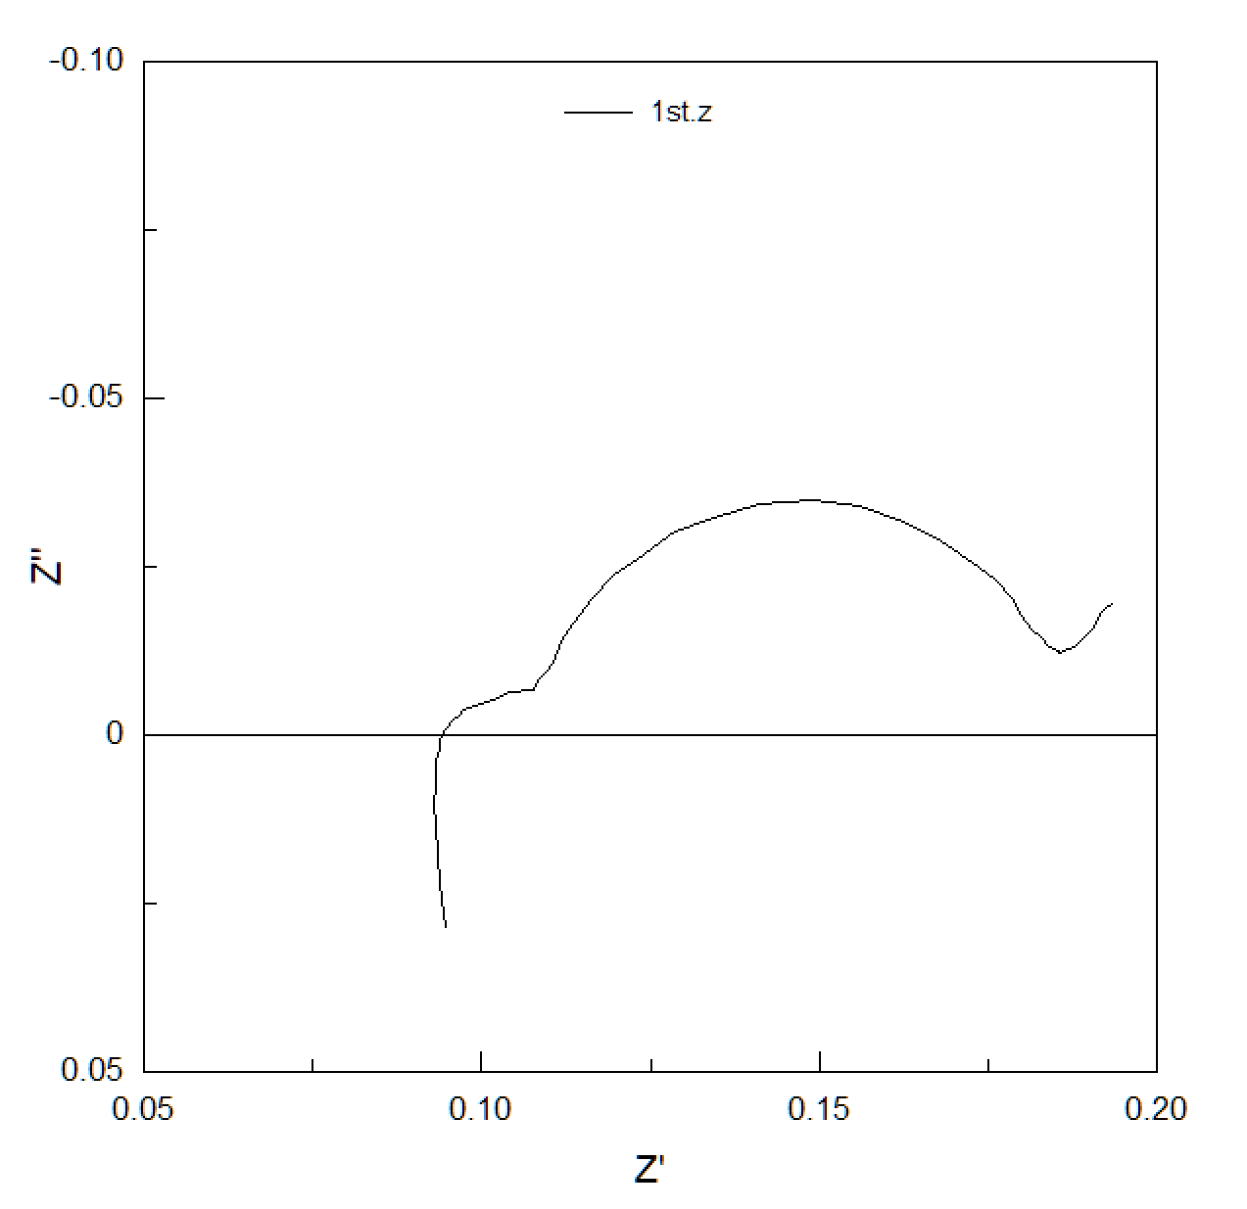

Figure 3‑8 Smoothed Data Curve

Data points below X axis reflect the condition of inductive resistance, which are unnecessary for impedance fitting. The same operations can be adopted to delete them. However, the pre-processing module in “Impedance.py” also has a method called “ignoreBelowX” to do a similar job.

### Fitting

The next job is to define the impedance model. In “Impedance.py”, models are defined as a string, where elements in series are separated by a dash, and elements in parallel are wrapped in a p( , ). In this thesis, ECM for this battery is as follows:

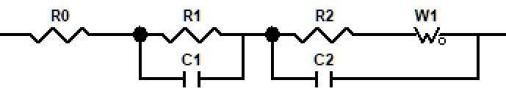

Figure 3‑9 Equivalent Circuit Model

Defined as: R0-p(R1,C1)-p(R2-Wo1,C2)

For each circuit, in order to fit the curve, an initial guess for each of the parameters is necessary. These initial guesses are passed in as a list in order the parameters are defined in the circuit string. The value of the parameters can be given by Zview as long as the magnitudes are consistent with the final fitting results. For the battery used in this experiment, a good guess is initial_guess = [.1, .01, .1, .05, .001, 20, 1], which means:

|  |  |
| --- | --- |
| Elements | Initial Guess |
| R0 | 0.1 (ohm) |
| R1 | 0.01 (ohm) |
| C1 | 0.1 (F) |
| R2 | 0.01(ohm) |
| C2 | 0.001(F) |
| W1_0 | 20 (ohm) |
| W1_1 | 1 (sec) |

Table 3‑2 Initial Guess for Fitting

Now the “.fit()” method can do the fitting job. The example results are:

Figure 3‑10 Sample Fitting Results

The final straight line reflects the Warburg impedance and it varies with the experiment. Therefore, in this case, only resistors are under consideration. Fitting results like Figure 3-10, where the arcs are completely fitted, are acceptable. Record the value of each resistors in a text file to generate training data.

## Machine Learning Implementation

For each piece of EIS test data, capture and record the value of each resistor to generate the training data. For example, in the circuit shown in Figure 3-8, the value of R0, R1 and R2, which represent , and respectively, are desired values for training, while in “impedance.py” package, the 0th, 1st and 3rd values should be recorded. In the data shown in Figure 3-5 and Figure 3-6, the vector can be written as:

1,0.07685459732219209,0.00994002577576287,0.05070810032910376

The number before each vector represents the number of cycles of the battery, which is also the prediction target of the machine learning model. By continuously performing the above process on each piece of EIS data, these values used to describe the characteristics of the curves can be used to form training data for machine learning. Figure 3-11 is the training data used in this thesis.

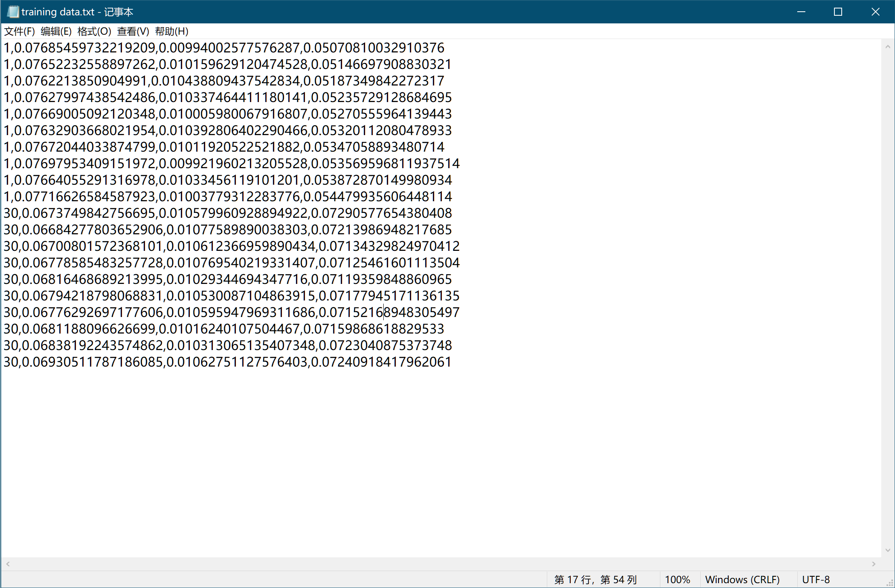

Figure 3‑11 Training Data

Both “Libsvm” and “scikit learn” include SVM methods in Python, however, “scikit learn” contains not only SVM but also KNN or other machine learning algorithms. Besides, it is also more convenient to search for the best parameters in “scikit learn”. Therefore, it is the most common used Python package in this thesis.

# Results and Analysis

This chapter shows the results of all the above operations, which includes fitting results, EIS results for multiple cycles, and machine learning results. The analysis will focus on the EIS results because their analysis results determine whether the algorithm can learn how the lithium-ion battery aging.

## Fitting Results

This section is to show the fitting results of “impedance.py”. As shown in Figure 4-1, 4-2 and 4-3, 10 fitting curves from 1st, 30th, and 50th cycles respectively are all able to fit the two arcs shown in original data. Thus, the resistance or each resistor can replace an entire curve in the original data to some extent, making the curve digitised in order to become inputs in machine learning.

Figure 4‑1 Fitting Results after the 1st Cycle

Figure 4‑2 Fitting Results after the 30th Cycle

All data can be found in Appendix A.2.

## EIS Results and Analysis

This section contains three parts. The first part shows how the capacity decays during the 30th and 50th periods.

Longitudinal comparison aims at comparing curves generated after different cycles, which is directly related to the SoH. This comparison fits with the desired research of this article, so the quantitative analysis is adopted.

In a sense, longitudinal analysis is an additional product of the experimentation. It compares the curve changes under the same cycle. These changes are usually caused by temperature and SoC. However, as such changes are not the focus of this thesis, only qualitative analysis was done here to inspire follow-up researches.

### Battery Aging Situation and SoH Calibration

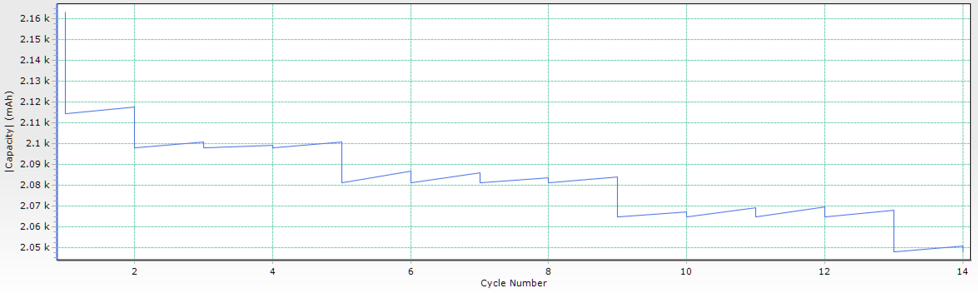

Figure 4‑3 Capacity vs Cycle number

Due to some preliminary verification work, the 30 cycles of the battery are not performed all at once. Figure 3-4 captures the changes in battery capacity from the 10th to the 25th cycle. It is not difficult to see from the figure that the capacity of the battery drops in stages during the cycle. Usually, after 3 to 4 cycles, the capacity drops significantly, and during the drop, there will be a big gap between the charged power and the released energy. Considering that the capacity remains 2080mah after 30cycles, the SoH value can be calculated to be 95% through the nominal capacity of 2200mah. Similarly, after 50 cycles, the capacity is still 2000mah. Therefore, the SoH calculation result is 91%.

So far, the number of cycles can correspond to the value of SoH:

|  |  |
| --- | --- |
| Number of Cycles | SoH |
| 1 | 100% |
| 30 | 95% |
| 50 | 91% |

Table 4‑1 Correspondence Table of Cycle Times and SoH

In this way, as long as the number of cycles is predicted and obtained by machine learning, the corresponding SoH value can be returned.

### Longitudinal Comparison (Quantitative)

#### Brand New Battery VS. Used Battery

Since many brand-new batteries have not been fully activated, the energy that can be released in the first few times is usually less than the energy that can be released after a few cycles. The battery used in the experiment is no exception. If simply look at the total resistance of the entire battery, they are often higher than the resistance of some used batteries, resulting in wrong SoH estimation.

However, from the EIS point of view, the difference between these two situations is obvious. Figure 4-4 shows the Nyquist diagram of the 1st cycle and the 30th cycle. In contrast with the meaning of each part explained in Figure 2-4, the changing trend of three kinds of resistance can be visualised, as shown in Figure 4-5.

Figure 4‑4 Nyquist Diagram of the 1st Cycle and the 30th Cycle

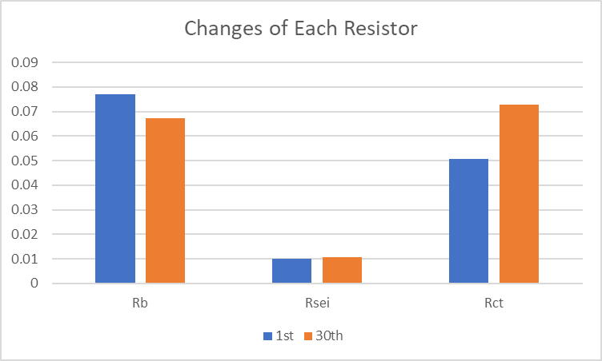

Figure 4‑5 Changes of Each Resistor (1st vs 30th)

It can be seen from Figure 4-5 that in the process of cycling, in addition to the increase in charge transfer resistance (), the ohmic resistance () decreases with the activation of the battery. Once the battery is activated, the ohmic resistance will not change for a long time.

From the first cycle to the 30th cycle, although the sum of the resistance values of the three resistors may first decrease and then go up, the changing trend of the single resistance value is certain. This provides a theoretical basis for machine learning to determine whether it is a new battery or a used one.

#### Battery After 30 Cycles VS. Battery After 50 Cycles

Figure 4-6 shows the Nyquist diagram of the 30th cycle and the 50th cycle. After separating each resistor, their change trends are shown in Figure 4-7.

Figure 4‑6 Nyquist Diagram of the 30th Cycle and the 50th Cycle

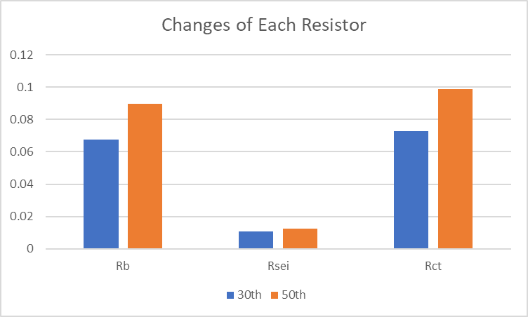

Figure 4‑7 Changes of Each Resistor (30th vs 50th)

During this period, both ohmic resistance and charge transfer resistance increase significantly. The ohmic resistance after 50 cycles even exceeds that of a brand-new battery. The resistance produced by the SEI layer is also showing signs of growth.

#### Summary of Battery Aging Mechanism

Combining the description of the aging of lithium-ion batteries in the first two sections, the corrosion of lithium-ion batteries can be simply divided into 3 stages by analogy with the wear of machine tools, as shown in Figure 4-8. It is worth noting that the following theory is based on the battery cycle at the allowable charge and discharge rate.

Figure 4‑8 3 Stages of Battery Corrosion

The first stage is the initial aging stage of the battery. The duration is usually several cycles. At this time, the electrodes are not fully activated, so the energy that can be released is less than the nominal capacity, but it does not mean that the capacity is lost. During this period, the ohmic resistance will continue to decrease, and the charge transfer resistance will increase with the number of cycles.

The second stage is the progressive aging stage. In this period, the ohmic resistance has dropped to a normal level and then increase rapidly. Meanwhile, since the cycle is always going on, the charge transfer resistance is simultaneously increasing. However, since this stage is the normal aging stage of lithium-ion batteries, the SEI layer has not yet been generated. Therefore, the resistance caused by it remains unchanged during this period.

The final stage is the rapid aging stage. At this time, the SEI layer has been formed, and the resistance caused by it will increase as the cycle progresses. Together with the increasing charge transfer resistance, the total resistance of the battery continues to increase in a non-linear manner, resulting in rapid capacity loss.

To summarise the changing trend of each resistor, the charge transfer resistance will keep increasing, while the ohmic resistance will drop down in the initial stage of aging and will continue to go up. However, resistance generated by the SEI layer only appears in the middle and late stages of aging.

### Horizontal Comparison (Qualitative)

Figure 4-9 shows 10 consecutive EIS curves after the 1st cycle. Also compared with Figure 2-4, it is found that the charge transfer resistance has a slight increase (Figure 4-10).

Figure 4‑9 Nyquist Diagram of Multiple Experiments After the 1st Cycle

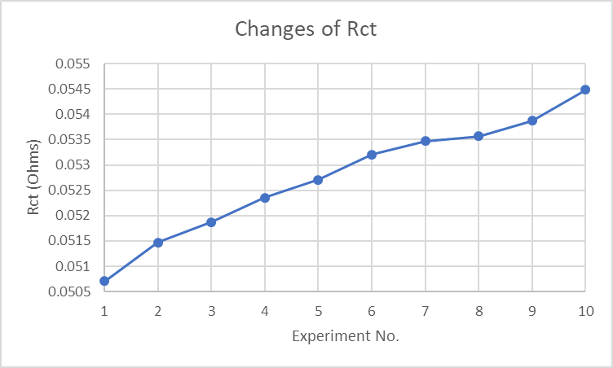

Figure 4‑10 Changes of Rct

In the course of several EIS experiments, the OCV of the battery rose from 4.11V to 4.12V, accompanied by a certain temperature rise. Refer to the OCV-SoC curve of the cell, it can be guessed that both temperature and SoC can cause the charge resistance to change.

## Machine Learning Results

Since there are 3 elements in the vector (, and ), it is difficult to display on a two-dimensional plane. Therefore, these 3 elements are separated into pairs to show the machine learning model.

Before training, all data will be plotted in a scatter chart, as shown in Figure 4-11, 4-12, and 4-13.

Figure 4‑11 R0 vs R1 Before Training

Figure 4‑12 R0 vs R2 Before Training

Figure 4‑13 R1 vs R2 Before Training

Even without relying on machine learning, it is easy to get that the boundary of Figure 4-12 should be a slash. In Figure 4-11 and 4-13, since the SEI layer has signs of formation, but considering the small increase in resistance, the boundary should be a straight line in a small range, but if zoom out the scatter plot, their boundaries should be slashes with very small slopes.

Figure 4‑14 R0 vs R1 After Training

Figure 4‑15 R0 vs R2 After Training

Figure 4‑16 R1 vs R2 After Training

As shown in Figure 4-14, 4-15, and 4-16, by using the “RBF” kernel function and CV trifold cross to search for the best parameters, the results confirm the previous conjectures.

In Figure 4-14, since the change of Rsei is small, it can distinguish the new battery from the used one well. From the machine learning perspective, for the given training data and battery model, batteries with Rb greater than 0.072 ohms tend to be regarded as new batteries, and vice versa.

Draw the resistance values of the three resistors on the X, Y, and Z axes, and the 3D decision boundary can be drawn as shown in Figure 4-17, where points falling in the blue area are considered to have 100% SoH, green area is 95%, and the yellow area is 91%.

Figure 4‑17 3D Decision Boundaries

Use the boundary plots as above, both human and machine learning model can distinguish new batteries (100% SoH) and batteries after 30 or 50 cycles (95% and 91% SoH respectively). For example, if a new piece of data is collected by a BMS showing that the resistances of each resistor after fitting are:

|  |  |  |
| --- | --- | --- |
| R0 | R1 | R2 |
| 0.0675 | 0.0104 | 0.0702 |

Table 4‑2 Example Data for Machine Learning SoH Estimation

The machine learning will return an approximate SoH value, which is 95%.

# Discussion

## Validation Process

There are two ways to verify the model, which are boundary plots and accuracy plots. Boundary plots use a graphical method to display the boundary, and the data points are marked along the boundaries to help visualise whether the boundaries are able to divide the data points evenly. Accuracy plots are bar charts that provide the accuracy of machine learning prediction given by different kernel functions.

After the machine learning model is generated, boundary plots are also generated between every two variables (R0 and R1, R0 and R2, R1, and R2). Verify the model by observing these three boundary plots.

By dividing the data into training data and testing data in advance, the generalisation ability of the machine learning model can be easily verified by checking the predicted result with the correct answer. Through the correct rate of the model, the most suitable kernel function can be selected.

## Validation Results

### Boundary Plot using Different Kernel Function

Linear Kernel Function:

Figure 5‑1 Decision Boundaries using Linear Kernel Function (R0 vs R1)

Figure 5‑2 Decision Boundaries using Linear Kernel Function (R0 vs R2)

Figure 5‑3 Decision Boundaries using Linear Kernel Function (R1 vs R2)

Polynomial Kernel Function:

Figure 5‑4 Decision Boundaries using Polynomial Kernel Function (R0 vs R1)

Figure 5‑5 Decision Boundaries using Polynomial Kernel Function (R0 vs R2)

Figure 5‑6 Decision Boundaries using Polynomial Kernel Function (R1 vs R2)

From the above figure, it can be found that the decision boundaries of the training model has only slightly differences from each other by using different kernel functions, especially for these relatively concentrated data. However, their training time is different. The polynomial kernel requires the most time, and the time required for the linear kernel and the RBF kernel is not much different.

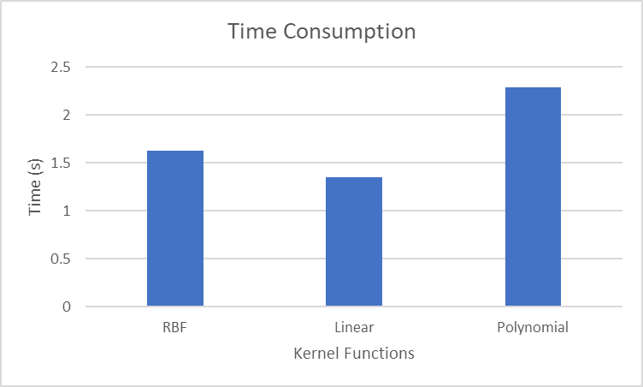

Figure 5‑7 Time Consumption Comparison

### Accuracy

Randomly divide the training data into two at a ratio of 7 to 3, of which the 7 are used as training data, and the 3 are used as verification data and put into the trained model. The selected verification data are shown in Table 5-1.

Table 5‑1 Verification Data

|  |  |  |  |
| --- | --- | --- | --- |
| Data No. | R0 | R1 | R2 |
| 1 | 0.06737498 | 0.01057996 | 0.07290578 |
| 2 | 0.06700802 | 0.01061237 | 0.0713433 |
| 3 | 0.07697953 | 0.00992196 | 0.0535696 |
| 4 | 0.06778585 | 0.01076954 | 0.07125462 |
| 5 | 0.07672044 | 0.01011921 | 0.05347059 |
| 6 | 0.08607709 | 0.01154582 | 0.0896983 |
| 7 | 0.0895637 | 0.01206921 | 0.09197608 |
| 8 | 0.08676389 | 0.01165889 | 0.09337448 |
| 9 | 0.08694703 | 0.01161352 | 0.09052772 |

After putting the above data into the model and comparing them with the correct answers, the results are as follows:

Table 5‑2 Validation Results

|  |  |  |  |
| --- | --- | --- | --- |
| Data No. | ML Estimation | Correct Answer | Correct or Not? |
| 1 | 30 | 30 | Correct |
| 2 | 30 | 30 | Correct |
| 3 | 1 | 1 | Correct |
| 4 | 30 | 30 | Correct |
| 5 | 1 | 1 | Correct |
| 6 | 50 | 50 | Correct |
| 7 | 50 | 50 | Correct |
| 8 | 50 | 50 | Correct |
| 9 | 50 | 50 | Correct |

The above results show that since the given training data is limited and mostly concentrated, the machine learning model can predict the target 100% accurately whether it is using RBF kernel function or the polynomial kernel function. This means that the target can be further divided (SoH 1% or 2% intervals).

# Conclusion

The work on this project started in early May and ended towards the end of August. Work is all done online due to COVID-19 pandemic. The project was started as an SoH assessment using EIS after multiple cycles. In addition to the provided solution, it has resulted a framework that can include various factors that can cause battery corrosion in future researches.

## Result Achieved

The thesis was successfully able to do battery cycles, extract and process EIS data from experiments. Subsequently, key features of the data were singled out to form a training data set for machine learning. The machine learning models generated by training data were able to predict the number of cycles and their accuracies were verified through test data randomly selected from the data set. As the number of cycles has a certain functional relationship with the SoH, the end goal of creating a machine learning based framework that reflects the batteries’ corrosion was achieved.

## Obstacles Faced

Due to the unprecedented circumstances of the COVID-19 pandemic, access to the laboratory is limited. All the experiments are done under a remote-controlled computer via TeamViewer. The pandemic has also affected the speed of logistics and blocked technical support from VersaSTAT. The cycle module for the battery to do charge and discharge had been delayed many times. This delay has also affected the progress of the experiments, making the battery unable to cycle to failure in order to get more data for machine learning before the thesis was submitted.

## Future Work

* **Find the best number of SoH states**

For the purpose of this project, only 3 states are defined, which are 1st (brand new), 30th and 50th. They correspond to specific percentages of SoH. However, both have not reached the point of failure. Setting proper number of states from brand new to failure can help keep balance between intuitiveness and generalisation ability of machine learning model.

* **Add more variables in training data**

As mentioned at the beginning of this chapter, factors like temperature and SoC will also affect the SoH status. Deviation from the working temperature will make a drop of SoH, while overcharging or discharging will also sharply reduce the energy that the battery can release. These factors can also be added into the training data in order to increase the flexibility of machine learning model.

* **Apply Kalman filter in multiple cells EIS testing**

When cells are connected in series or parallel in the actual EVs, the small voltage amplitude applied in EIS testing also brings a slightly current change, which brings difficulties for current sensor to measure them. The Nyquist curve will then become a mess and results in inaccuracy in impedance calculation. At this time, simply increasing the amplitude of the voltage to increase the signal-to-noise ratio will improve, but excessive voltage will lead to safety hazards. Kalman filter can correct these values by combining the observed and predicted values in different weights, which is an effective method to improve the reliability of impedance calculation in low voltage amplitude circumstances.

REFERENCES

Insert list of references here

APPENDICES

CURES Approval

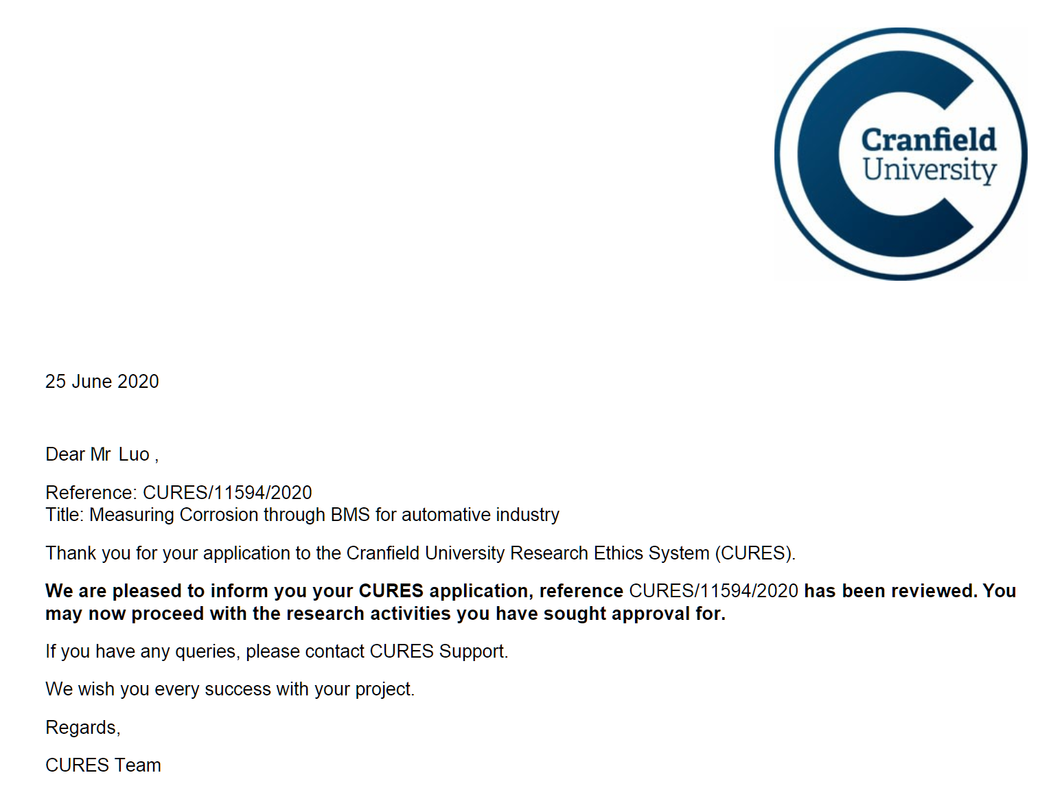

Battery Data

Battery data available at: <https://github.com/Urutora96/Machine-Learning-Based-Battery-SoH-Prediction>